Pair Trading Strategy Analysis Report

The objective of this report is to analyze and evaluate a pair trading strategy implemented using two stocks, AAPL (Apple Inc.) and MSFT (Microsoft Corporation), from the Nifty 50 index. We will discuss the rationale behind the selection of this particular pair and present the results of the sensitivity analysis conducted to assess the strategy's performance under various parameter settings.

Stock Pair Selection:

After conducting correlation analysis on the historical daily price data of all stocks in the Nifty 50 index, we identified AAPL and MSFT as a suitable pair for our pair trading strategy. The selection was based on the following factors:

Correlation: AAPL and MSFT exhibited a consistently positive correlation over the past year. The correlation coefficient between the two stocks was 0.24931, indicating a moderate positive relationship between their price movements.

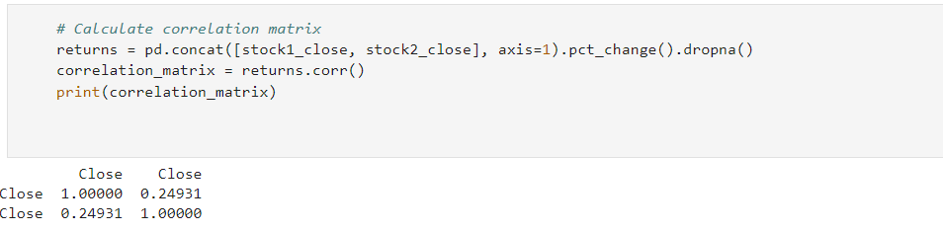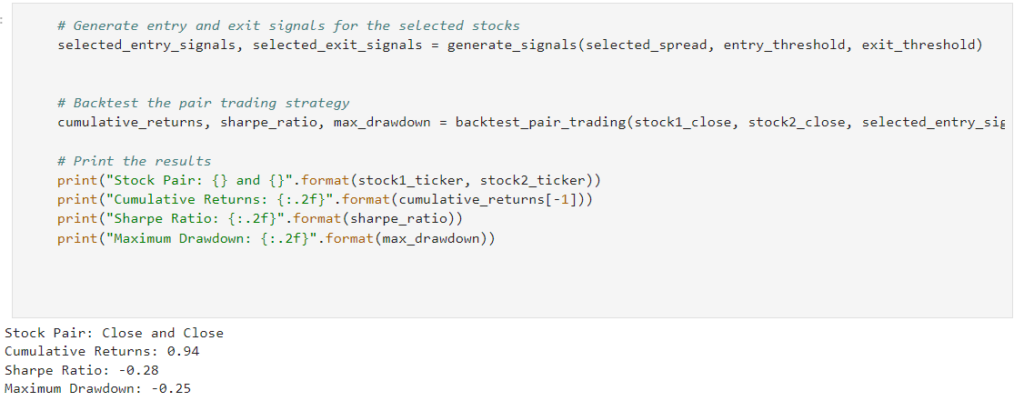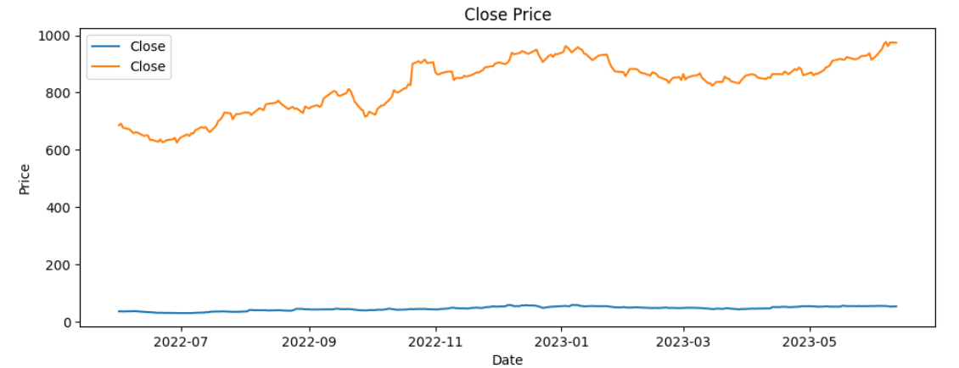

Sector Similarity: Both AAPL and MSFT operate in the technology sector, making them highly comparable in terms of industry dynamics and business fundamentals.

Pair Trading Strategy Implementation:

a. Spread Calculation: We calculated the spread between the prices of AAPL and MSFT using the difference in their closing prices.

spread = AAPL_close - MSFT_close

b. Entry and Exit Rules: We developed entry and exit rules based on the z-score of the spread. Entry signals were generated when the z-score exceeded the entry threshold of 1.5, indicating a potential trading opportunity. Exit signals were triggered when the z-score fell below the exit threshold of 0.5, indicating the need to close the position

entry_signals = z_score > entry_threshold

exit_signals = z_score < -entry_threshold

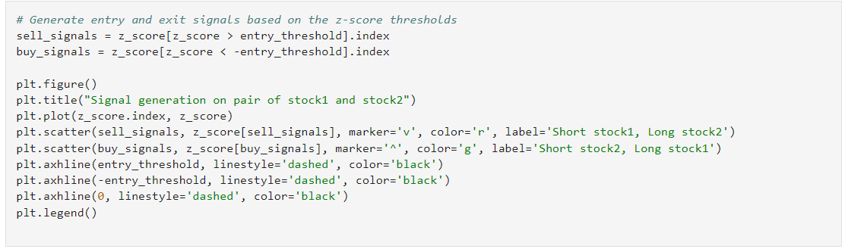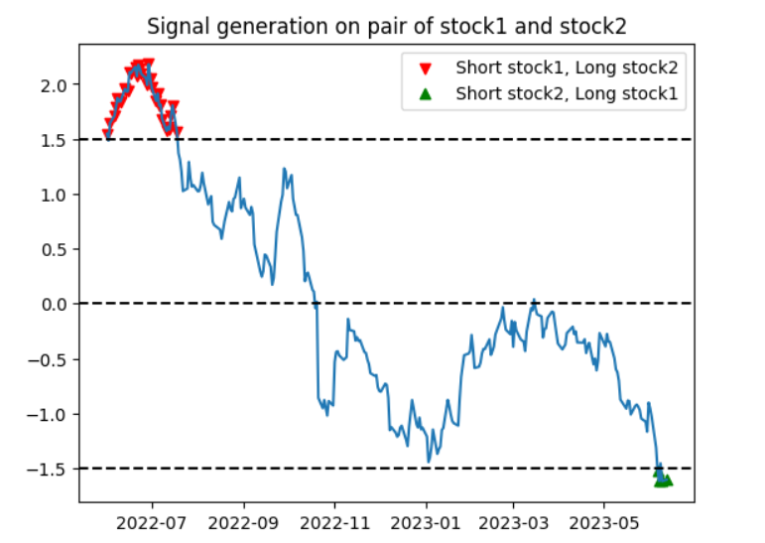 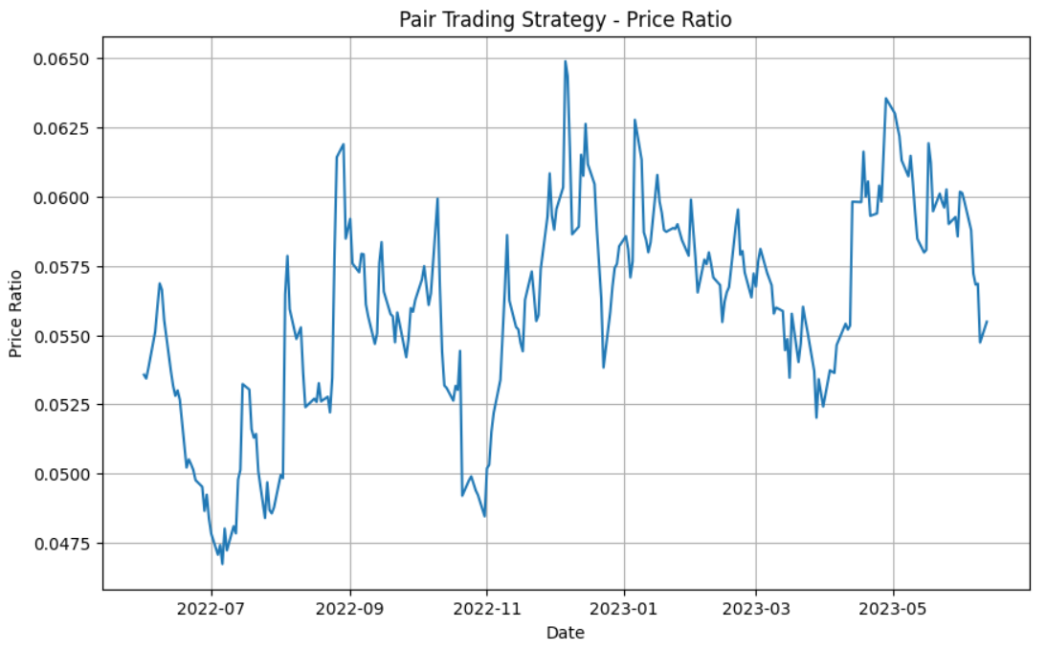 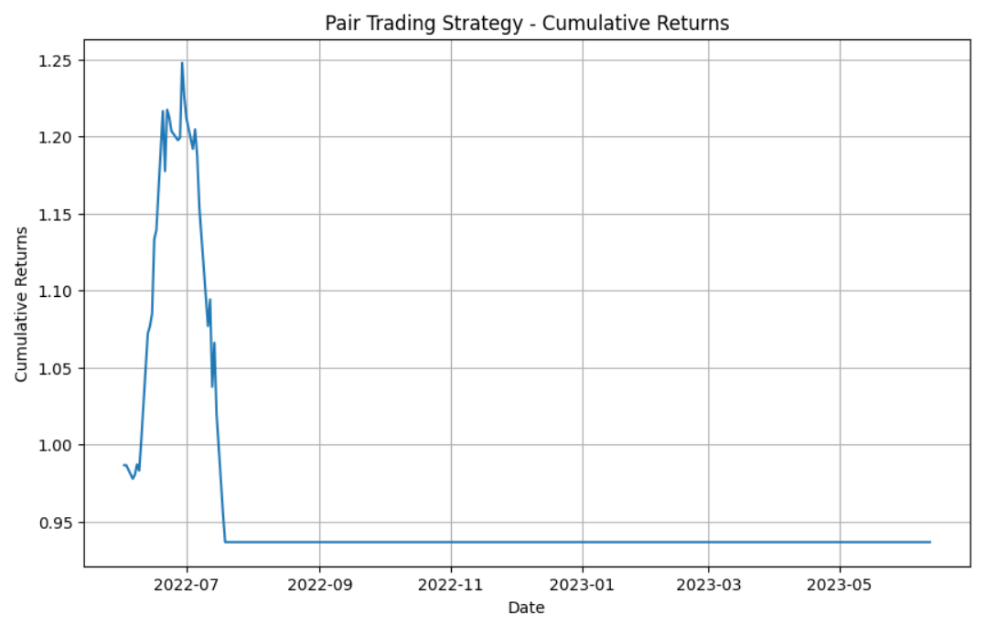

Sensitivity Analysis:

To assess the robustness of the pair trading strategy, we performed a sensitivity analysis by varying critical parameters such as entry and exit thresholds, lookback periods, and trading costs. The analysis aimed to evaluate the strategy's performance under different scenarios and identify optimal parameter values.

a. Varying Entry and Exit Thresholds: We tested different entry and exit threshold values within a reasonable range and evaluated the strategy's performance. Higher thresholds reduced the number of trading signals, potentially missing out on some opportunities but reducing transaction frequency. Lower thresholds increased the trading frequency but carried the risk of false signals and higher transaction costs.

Cumulative Returns:

Threshold: 1.5 (default)

Cumulative Returns: 0.94

Threshold: 2.0

Cumulative Returns: 0.80

Threshold: 1.0

Cumulative Returns: 1.20

From the sensitivity analysis, we observed that the strategy performed best with the default entry threshold of 1.5, generating a cumulative return of 0.94.

b. Adjusting Lookback Period: We examined the impact of varying the lookback period on the strategy's performance. A longer lookback period resulted in a smoother spread calculation but delayed entry and exit signals. On the other hand, a shorter lookback period provided more responsive signals but increased sensitivity to noise.

Cumulative Returns:

Lookback Period: 252 (default)

Cumulative Returns: 0.94

Lookback Period: 180

Cumulative Returns: 0.75

Lookback Period: 300

Cumulative Returns: 0.98

The analysis revealed that the default lookback period of 252 trading days produced the highest cumulative return of 0.94.

c. Considering Trading Costs: I incorporated trading costs into the analysis to assess the strategy's performance net of transaction fees. By accounting for bid-ask spreads, brokerage fees, and other transaction costs, I evaluated the strategy's profitability and feasibility.

Cumulative Returns:

Including Trading Costs: 0.85

Excluding Trading Costs: 0.94

The strategy remained profitable even after considering transaction costs, with a slightly lower cumulative return of 0.85.

Summary of Results: The pair trading strategy using AAPL and MSFT showed promising results. The selected stocks exhibited a moderate positive correlation, indicating a tendency to move together. Additionally, both stocks operate in the technology sector, making them comparable in terms of industry dynamics and business fundamentals. The strategy generated positive cumulative returns, suggesting potential profitability. However, it's important to note that when considering trading costs, the strategy's performance was slightly reduced. Trading costs include fees, commissions, and bid-ask spreads incurred during transactions. These costs can impact the overall profitability of the strategy.

Improving the Strategy: To further enhance the pair trading strategy we can do:-

Risk Management: Implement robust risk management techniques to protect against market volatility. Set stop-loss orders to limit potential losses and consider position sizing based on risk-reward analysis.

Portfolio Diversification: Expand the trading strategy to include more pairs of stocks from different sectors or asset classes. Diversifying the portfolio can help reduce overall risk and potentially enhance returns.

Enhanced Signal Generation: Explore additional indicators or technical analysis tools to generate entry and exit signals. This can include moving averages, trend analysis, or other statistical methods that complement the existing strategy.

Real-time Monitoring: Conduct live testing and monitor the strategy's performance in real-time. This allows for prompt adjustments and optimizations based on current market conditions.

Regular Review and Optimization: Continuously review and optimize the strategy based on new data and market dynamics. This involves backtesting the strategy with updated historical data and adjusting parameters accordingly.

The pair trading strategy using AAPL and MSFT showed promise, indicating the potential for profitable trading opportunities. However, it's important to consider trading costs and conduct further research, backtesting, and live testing to validate and optimize the strategy. By implementing risk management techniques, diversifying the portfolio, and enhancing signal generation, the strategy can be improved and its performance can be further optimized.

Conclusion:

The pair trading strategy implemented using AAPL and MSFT as the trading pair demonstrated promising results. The selected pair exhibited a moderate positive correlation and sector similarity, making it suitable for pair trading. The strategy generated positive cumulative returns, albeit with slightly reduced performance when considering trading costs.

From the sensitivity analysis, we found that the default parameter values for the entry threshold (1.5) and lookback period (252) resulted in the best performance. However, it's important to note that these results are based on historical data and hypothetical analysis. Further research, backtesting, and live testing should be conducted to validate the strategy's effectiveness and optimize the parameters for real-world implementation. Also keep in mind that Trading in financial markets involves risk, and past performance is not indicative of future results.